Corrosion inhibition by caffeine and caffeine – I⁻ system for CT38 steel in 1M hydrochloric acid solution
Truong Thi Thao, Hoang Thu Tra
Collegue of Science, Thai Nguyen University
Abtracts:
The inhibition efficiency of caffeine and caffeine - KI system in controlling corrosion of CT38 steel immerased in acid 1M HCl solution has been evaluated in the absence and presence of them by weight loss method. Influence of caffeine concentration, temperature and immersion peroid on the inhibition efficiency of the 1.0g/l caffeine - 1%KI system has also investigated. The results of the study reveal that the inhibition efficiency of caffeine for CT38 steel corrosion in 1M HCL vary with concentration; the inhibition efficiency of the 1.0g/l caffeine - 1%KI system increases compared with only use caffeine and changes is not much when increasing in temperature, extending the trial periods. Thermodynamic consideration reveals that adsorption caffeine on CT38 steel surface is spontaneous and occurs according to Langmuir adsorption isotherm. Physical adsorption mechanism has been proposed for the adsorption of the inhibitor from the trend of the inhibiton efficiency with temperature and the values of some kinetic and thermodynamic parameters obtained.
Key words: Corrosion inhibition, steel, Langmuir adsorption isotherm, caffeine, KI.
1. Introduction
Environment friendly inhibitors have attracted the attention of researchers. Non-toxic natural products have been widely used as corrosion inhibitors. Extracts of plants such as green tea, tobaco, café,... have shown good and scale inhibitors [1, 2, 4-7]. These extracts contain caffeine. So that, caffeine was isolated from dry green tea leaves and used as corrosion inhibitor [2]. The present work (i) evaluates the inhibition efficiency of caffeine concentration, of 1g/l caffeine - 1%KI system in controlling corrosion of CT38 steel in 1M HCl acid solution, (ii) examines the inhibition efficiency of 1g/l caffeine - 1%KI system when increasing in temperature, extending the trial periods, (iii) observes microscopic surface by SEM method, (iv) calculates kinetic parameters and thermodynamics from experimental results [3].
2. Experimental
CT38 Steel (produced in Thai Nguyen) specimens (steel containing 0.154%C; 0.636%Mn; 0.141%Si; 0.019%P; 0.044%S and the rest Fe) of dimensions with 5.0x5.0x0.2cm. Prior to each experiment, specimens were removed oil, pickled, washed several times with distilled water then with ethanol, dried with acetone and preserved in a desiccator 1day; weighted and measured accurately sample size before immered in 170ml of the test solution in an open beaker. For each sample, three tests are realized and the corresponding average value is calculated. The immersion time for weight loss amounts is 24h for all the temperatures and 1 to 10 days to investigate influence of times. After each experiment, specimen were pickled (500ml of water, 500ml of 37% HCl and 7g/l urotropine), washed several times with distilled water then with ethanol, dried with acetone, re-weighted and preserved in a desiccator 1day to test again. The samples were weighted with an uncertainty of 10-4g.
The acidic solution 1M HCl was prepared by dilution of Analytical Grade 37% HCl with distilled water without and with the inhibitor (caffeine concentration of 0.01g/l to 5.0g/l; 1.0g/l caffeine - 1%KI system) to define the corrosion rate of steel. Chemicals used are analytical grade, caffeine extracted from dry Thai Nguyen green tea leaves. The corrosion rate (V), corrosion inhibition efficiency (IE) and degree of surface coverage (θ) was caculated using equation 1,2 and 3:
V = [m_{o} - m_{t}]/Sxt (1)
IE = 100 [1-V₂/V₁]% (2)
θ = 1-V₂/V₁ (3)
where m_{o} and m_{t} are the weight of specimen (in grams) before and after experiment; V₁ and V₂ are the corrosion rate (g/cm².day) of CT38 steel in the presence and absence of inhibitor in 1M HCL acid solution, respectively; θ is the degree of surface coverage of the inhibitor; S is the area of the specimen (in cm²) and t is the period of immersion (in days).
Specimens which surface examination study after immersion period were taken out, rinsed lightly under running water, dried quickly in air, preserved closely and analysed by SEM method.
3. RESULTS AND DISCUSSION
3.1. Corosion inhibition by caffeine and adsorption consideration
The corrosion rates of CT38 steel when it is immersed in 1M HCl solution in the absence and the presence of various concentrations of caffeine, for a period of 1 day, are given in Table 1. It is observed that, as the concentration of caffeine increases, the inhibition efficiency increases gradually from 0.01g/l to 1.0g/l; at the concentration of caffeine larger 1.0g/l, as the concentration of caffeine increases, the inhibition efficiency does not increases much.
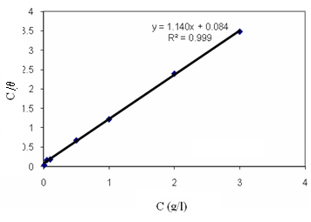
Tab. 1: Corrosion rates of CT38 steel immersed in 1M HCL solution for 1 day and inhibition efficiency of caffeine
C (g/l) | v_{tb}x10² (g/cm².day) | IE (%)
0.00 | 2.86
0.01 | 2.61 | 8.97
0.05 | 2.34 | 18.29
0.10 | 1.43 | 50.12
0.50 | 0.73 | 74.53
1.00 | 0.36 | 87.60
2.00 | 0.31 | 89.31
3.00 | 0.18 | 93.62
5.00 | 0.21 | 92.65

Fig. 1: Langmuir isotherm for the adsorption of caffeine on the surface of CT38 steel in 1M HCl

The adsorption characteristics of caffeine were also investigated by fitting data obtained for the degree of surface coverage into different adsorption isotherms. The tests indicate that Langmuir adsorption isotherm best describes the adsorption behaviour of caffeine. The assumptions of Langmuir adsorption isotherms can be expressed as follows [4, 5]:
(4)
where C is the concentration of the inhibitor in the bulk electrolyte, θ is the degree of surface coverage of the inhibitor and K is the adsorption equilibrium constant.
Fig. 1 shows Langmuir adsorption isotherm for the adsorption of caffeine on CT38 steel surface.
Values of adsorption parameters deduced from the isotherms are: R² = 0.9994, K = 13.57 and ΔGº = -16.415 (kJ/mol). From the results obtained, it is significant to note that the R² values and the slopes’values of the plots are very close to unity, which indicates a strong adherence of the adsorption data to the assumptions establishing Langmuir adsorption isotherm. Also, the application of Langmuir adsorption isotherm to the adsorption of caffeine on the surface of CT38 steel suggests that, there is no interaction between the adsorbed species. Values of adsorption equilibrium constant determined from the slope of the Langmuir adsorption isotherms were used to calculate the free energies of adsorption of caffeine on CT38 steel surface using equation 5 [4,5],
ΔG_{ads}=-2.303 RTlog(55.5K) (5)
where ΔG_{ads} is the free energy of adsorption, R is the gas constant, T is the temperature and 55.5 is the molar concentration of the water in the solution.
Calculated values of ΔG_{ads} is –16.415KJ/mol for adsorption at 298K. The values are negative and are less than the threshold value of -40 KJ/mol required for chemical adsorption, hence the adsorption of caffeine on CT38 steel surface is spontaneous and is consistent with the mechanism of physical adsorption.
Values of the heat of adsorption of caffeine on the surface of CT38 steel were calculated using equation 6 [4,5]:
ΔH_{ads} = 2,303Rx$\frac{T_{1}{\text{xT}}_{2}}{T_{2}−T_{1}}$$\left[\text{log}\frac{θ_{2}}{1−θ_{2}}−\text{log}\frac{θ_{1}}{1−θ_{1}}\right]$ (6)
where ΔH_{ads} is entanpi of adsorption (kJ/mol); T₁, T₂ are test temperatures, respectively; θ  and θ₂ are the degree of surface coverage of the inhibitor at corresponding temperature.
Calculated values of ΔH_{ads} are ranged from -4,420 kJ/mol to -13,307kJ/mol, indicating that the adsorption of caffeine on the surface of CT38 steel is exothermic. This is another indication that the adsorption process is essentially physical adsorption.
3.2. Inhibition efficiency of 1g/l caffeine – 1%KI system compare with 1g/l caffeine
The result of 3.1 shown that, at the concentration of caffeine larger 1.0g/l, as the concentration of caffeine increases, the inhibition efficiency does not increases much. So caffeine concentraiton of 1g/l was used with 1%KI to inhibit corrosion of CT38 steel in 1M HCl solution.
Effect of immersion time
Values of corrosion rates of CT38 steel in test solutions and inhibition efficiencies of caffeine, system of caffeine - KI for the corrosion of CT38 steel in 1M HCl are presented in Table 2.
Tab. 2: Corrosion rates and inhibition efficiencies of inhibiors for the corrosion of CT38 steel in 1M HCl follow immersion times
Times (days) | solution | V (g/cm².day) | IE (%)
1 | 1M HCl | 0.0291
1 | 1M HCl + 1.0g/l caffeine | 3.673.10⁻³ | 87.40
1 | 1M HCl + 1.0g/l caffeine + 1.0%KI | 3.967.10⁻⁴ | 98.63
3 | 1M HCl | 0.0166
3 | 1M HCl + 1.0g/l caffeine | 3.272.10⁻³ | 80.29
3 | 1M HCl + 1.0g/l caffeine + 1.0%KI | 3.186.10⁻⁴ | 98.08
6 | 1M HCl | 0.0108
6 | 1M HCl + 1.0g/l caffeine | 2.489.10⁻³ | 76.85
6 | 1M HCl + 1.0g/l caffeine + 1.0%KI | 2.020.10⁻⁴ | 98.58
10 | 1M HCl | 6.540.10⁻³
10 | 1M HCl + 1.0g/l caffeine | 1.540.10⁻³ | 76.45
10 | 1M HCl + 1.0g/l caffeine + 1.0%KI | 1.931.10⁻⁴ | 97.05
Tab. 2 shown that: the corrosion rates of CT38 steel decrease with increase in the immersiont time. In 1M HCl solution presence of 1.0g/l caffeine, the corrosion rates significantly reduced, the inhibition efficience is ~80%, the immersion times increase, the effiency decrease lightly (from ~87% to ~76%); as inhibitors are 1.0g.l caffeine – 1% KI mixture, the corrosion rates reduced much more, the inhibition efficience is ~98%, the immersion times increase, the effiency does not change significantly.
Effect of temperature
Effect of temperature to corrosion inhibition ability of 1.0 g/l caffeine and 1.0g/l caffeine - 1.0% KI system for the corrosion of CT38 steel in 1M HCl for 1 day was done at 308K and 318K in a thermostated bath . The result obtained from experiment are presentes in table 3.
Tab. 3: Corrosion rates and inhibition efficiencies of inhibiors for the corrosion of CT38 steel in 1M HCl at different temperatures.
Temperature (K) | solution | V (g/cm².day) | IE (%)
308 | 1M HCl | 0.0334
308 | 1M HCl + 1.0g/l caffeine | 4.953.10⁻³ | 85.13
308 | 1M HCl + 1.0g/l caffeine + 1.0%KI | 7.137.10⁻⁴ | 97.86
318 | 1M HCl | 0.0439
318 | 1M HCl + 1.0g/l caffeine | 6.099.10⁻³ | 86.11
318 | 1M HCl + 1.0g/l caffeine + 1.0%KI | 1.029.10⁻³ | 97.65
Tab. 3 shown that: as temperature increase, the inhibition eficiency of 1.0 g/l caffeine and 1.0g/l caffeine - 1.0% KI system for corrosion CT38 in 1M HCl relatively stable. It indicate that: caffeine and caffeine - KI system have good behavior at temperatures around room temperature.
The effect of temperature on the corrosion of CT38 steel in the absence and presence inhibitors were also investigated by fitting data obtained follows Arrhenius equation (7) and Fig. 2:
V = A.e^{-E*/RT} or logV = -E*/2.302xRT + logA (7)
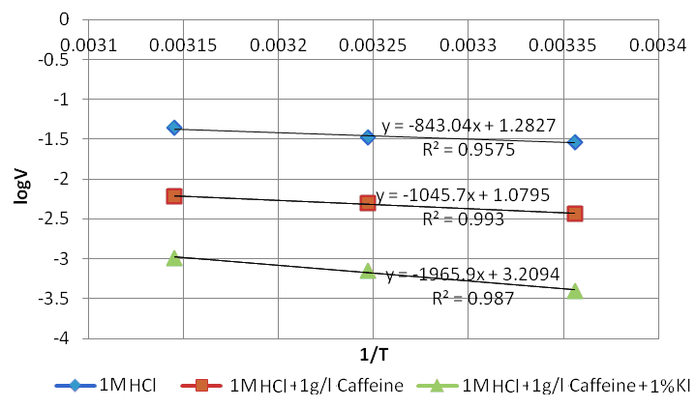
where V is the corrosion rate of CT38 steel at the temperatures T, E* is the activation energy and R is the gas constant.
Fig. 2: Arrhenius equation for the corrosion CT38 steel in HCl 1M in the absence and in the presence of inhibiotrs
From the results obtained, it note that the R² values is very close to unity, which indicates the assumptions establishing Arrhenius equation.
Values of E* calculated from equation (9) are: E*_{1M HCl} =16,135 kJ/mol; E*_{1M HCl + 1.0g/l caffeine} = 20,011 kJ/mol; E*1M HCl + 1.0g/l caffeine + 1.0% KI = 37,066 kJ/mol. These values are less than the threshold value of 80KJ/mol required for chemical adsorption, hence the adsorption of caffeine on CT38 steel supports the mechanism of physical adsorption. These values describe that apparent activation energy increased with using inhibitors. It shown that: 1.0 g/l caffeine and 1.0g/l caffeine - 1.0% KI system are agent increasing the activation energy, causing iron dissolution process occurs more difficultly. It mean that they reduce corrosion. E*1M HCl + 1.0g/l caffeine + 1.0% KI > E*_{1M HCl + 1.0g/l caffeine} mean that 1.0g/l caffine - 1.0% KI system make corrosion CT38 in 1M HCl required higher activation energy than 1.0g/l caffeine; reduce corosion stronger. This result is entirely consistent with the experimental.
3.3. Scanning electron Microscope (SEM)
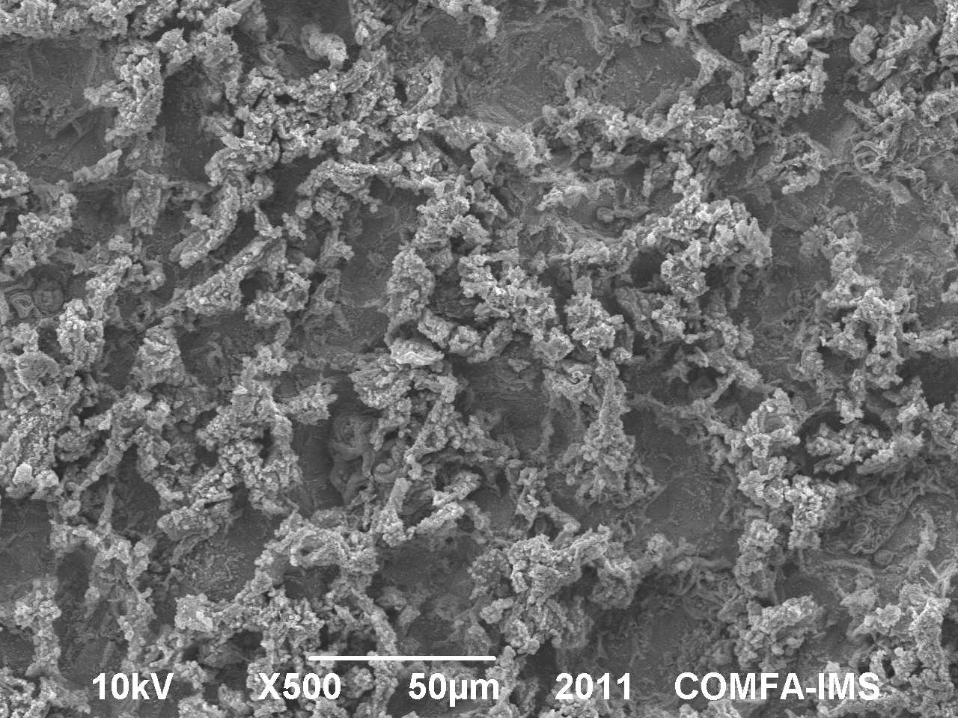
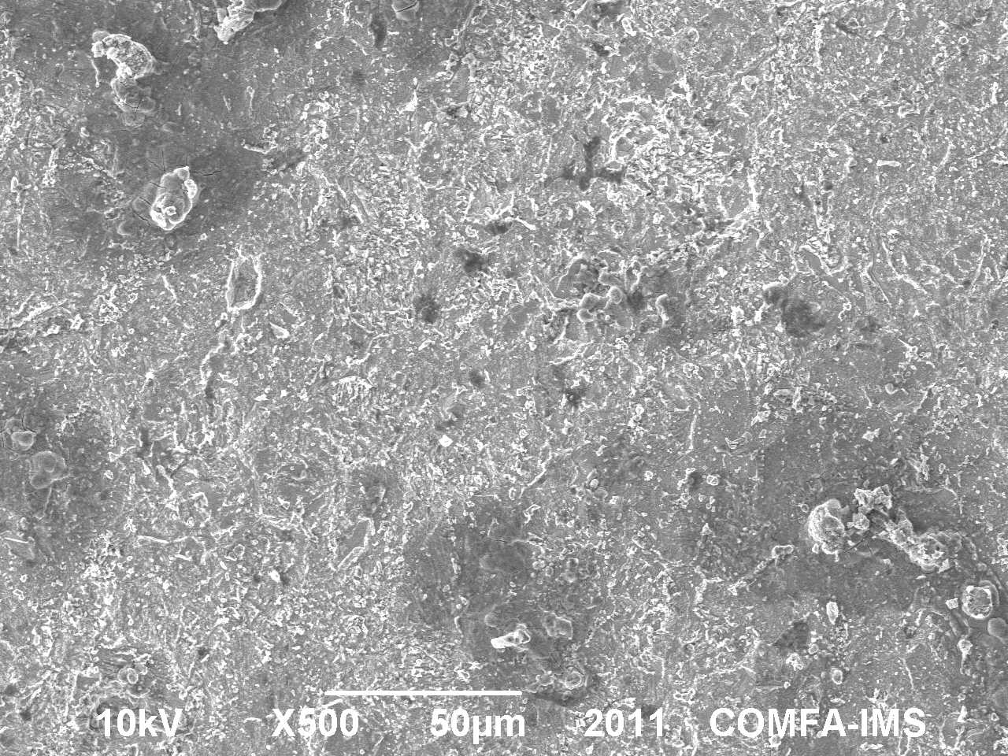
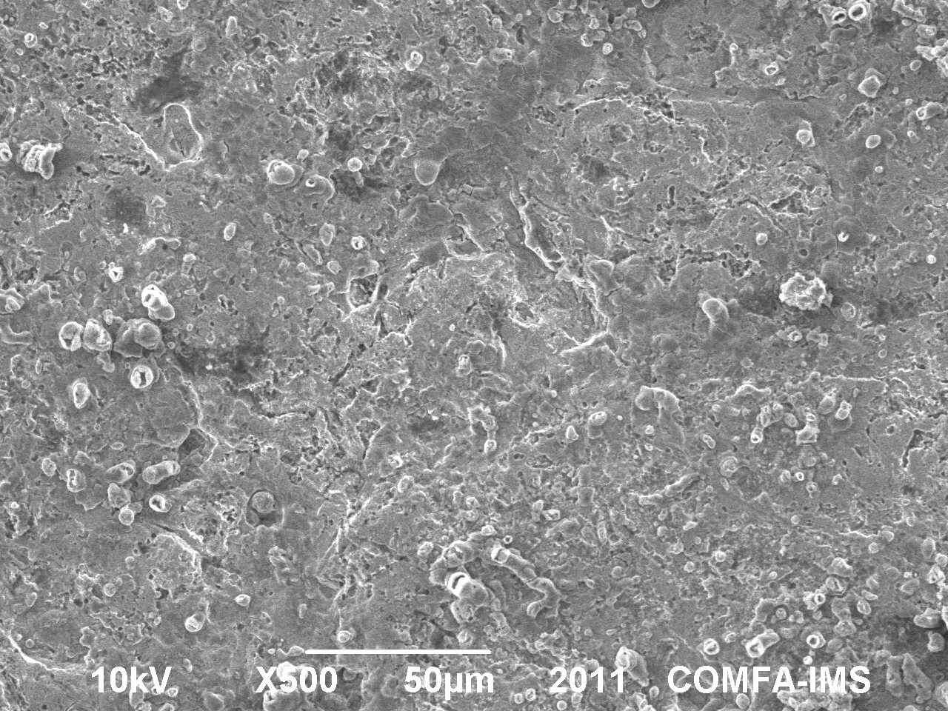
Fig. 3 shows the SEM micrographs of CT38 steel after immersion in the 1M HCl solution with the absence and presence of inhibitors.
a. 1.0M HCl , 298K b. 1.0M HCl + caffein, 298K c. 1.0M HCl + caffein + KI, 298K

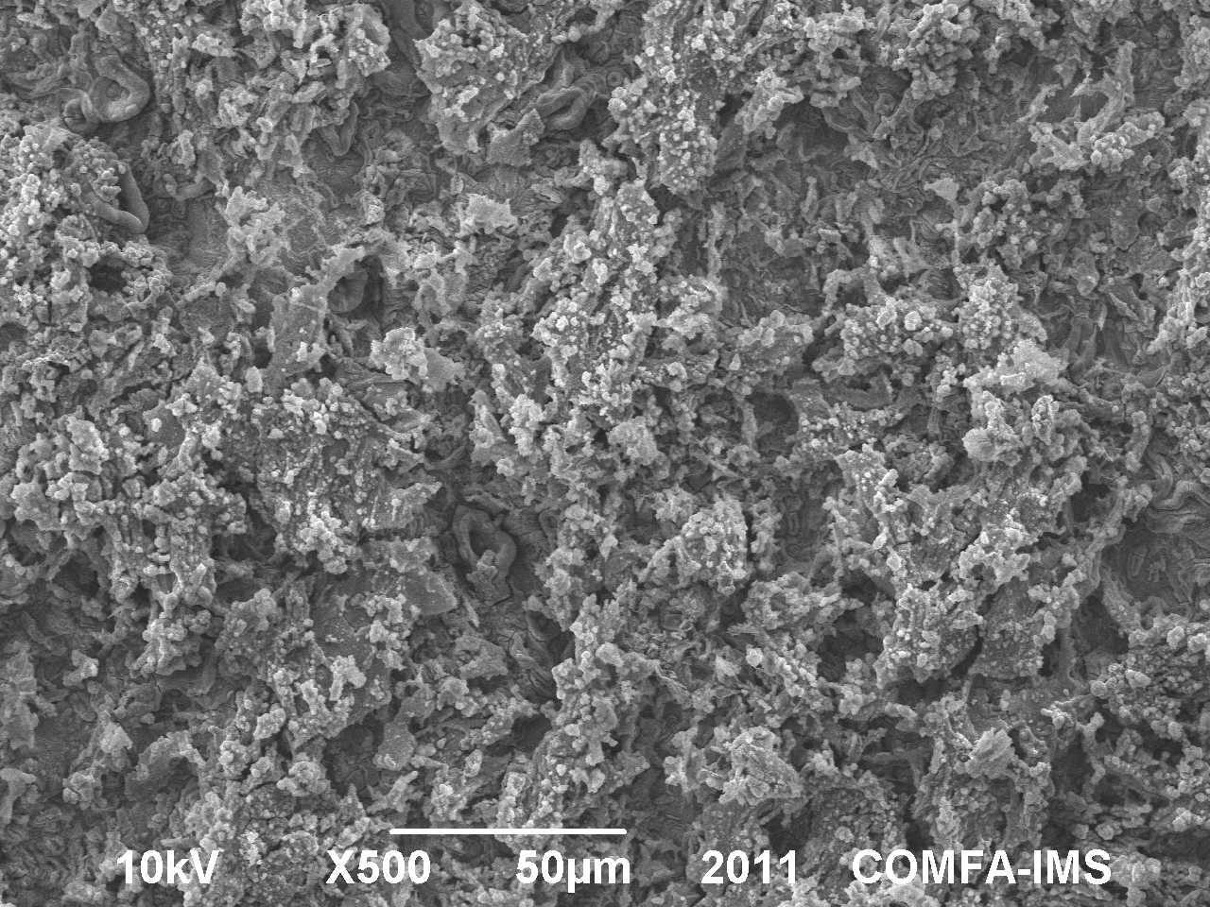
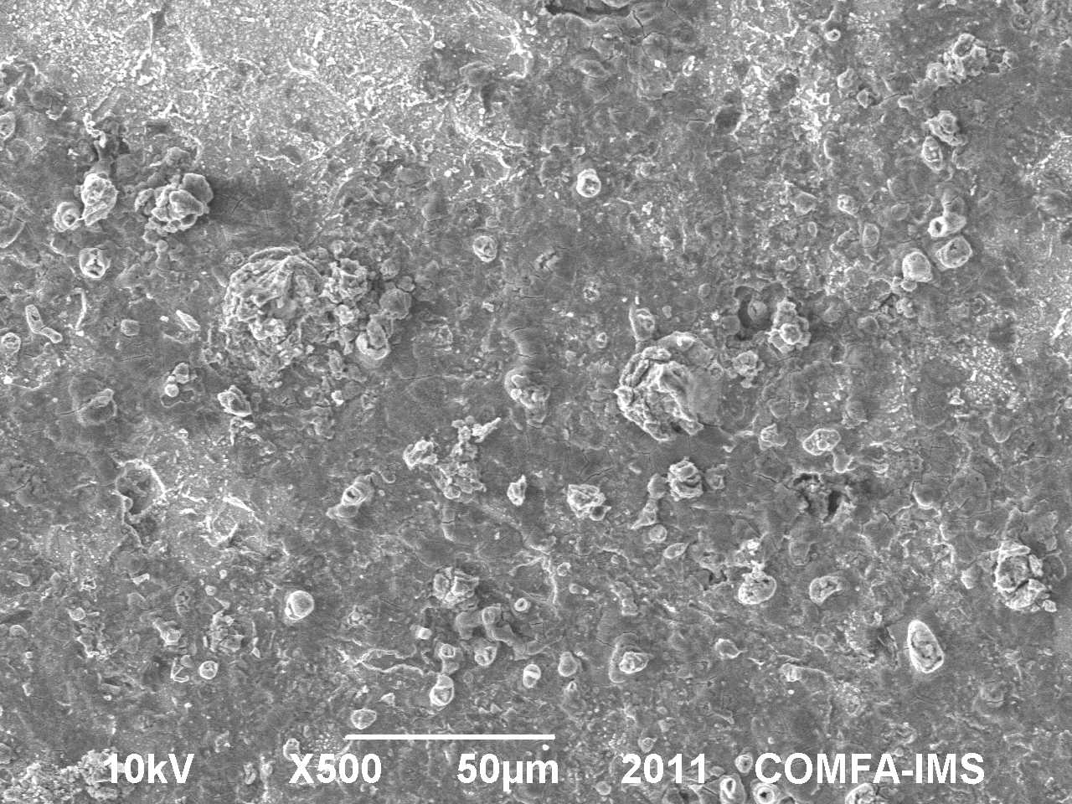
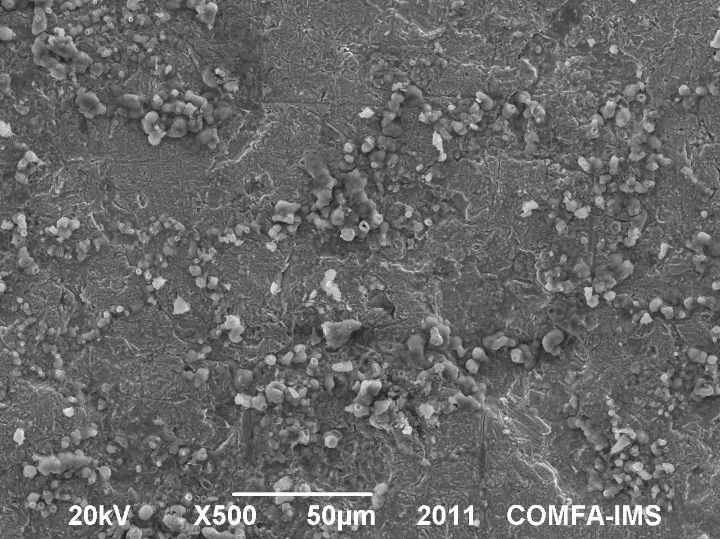
d. 1.0M HCl , 308K e. 1.0M HCl + caffein, 308K f. 1.0M HCl + caffein + KI, 308K
Fig. 3. SEM micrographs of Thai Nguyen steel in without and with inhibitor at different temperatures
Here, the micrograph exhibited many plots of corrosion on the surface of sample which immersion in the solution with the absence of the inhibitor. The density and the size of the corrosion point on the CT38 steel surface decreased when inhibitors are present in the solution. The reduction in the present of 1.0g/l caffeine – 1.0%KI system is stronger than in the presence of 1.0g/l caffeine. It means that 1.0 g/l caffine and 1.0g/l caffine - 1.0% KI system are good inhibitors for corrosion of CT38 steel in the 1M HCl solution. And of course, as the temperature rises, the density and the size of the corrosion point increase.
4. CONCLUSIONS
1. Inhibition efficiency increases with the increase in caffeine concentration, but slight decreased as prolong immersion time and increase temperature.
2. The corrosion process is inhibited by adsorption of the caffeine on the steel surface following the Langmuir adsorption isotherm. The adsorption is spontaneous, exothermic and physical adsorption.
3. The combination 1.0g/l caffeine and 1.0% KI increases strongly inhibition efficiency for corrosion of CT38 steel in 1.0MHCl compare with 1.0g/l caffeine (from ~80% to ~97%). The inhibition efficiency does not change much as prolong immersion time to 10 days and increase temperature to 318K.
4. All caffeine and caffeine – KI system increase activation energy and decrease corrosion rate for corrosion process. All caffeine and caffeine – KI system are corrosion inhibitors. Caffeine – KI system is better inhibitor than only use caffeine.
REFERENCES
- Pham Thu Giang, V.T.T.Ha and L.Q.Hung, "Screening Vietnamese natural products for new environmentally friendly materials for corrosion protection", International scientific conference on ‘Chemistry for Developmant and Integration’, 2008, 977-985.
- Trương Thi Thao (2012), Study the electrochemical properties and corrosion inhibition ability of some natural compounds, PhD thesis in Chenistry, Institute of Chemistry, Vietnam Academy of Science and Technology.
- Hoang Thu Tra (2012), Using combination halogenua and caffeine inhibit corrosion for CT38 steel in acit emvironment, Graduate thesis, Collegue of Science, Thai Nguyen University.
- E. E.Ebenso, N.O.Eddy and A.O.Odiongenyi (2008), “Corrosion inhibitive properties and adsorption behaviour of ethanol extract of Piper guinensis as a green corrosion inhibitor for mild steel in H2SO4”, African Journal of Pure and Applied Chemistry Vol. 2 (11), pp. 107-115
- I.B.Obot, N.O.Obi-Egbedi, S.A.Umoren, E.E.Ebenso (2010), “Synergistic and Antagonistic Effects of Anions and Ipomoea invulcrata as Green Corrosion Inhibitor for Aluminium Dissolution in Acidic Medium”, Int. J. Electrochem. Sci.,V 5, p 994 – 1007.
- S.A.Umoren, O.Ogbobe, I.E.Igwe, E.E.Ebenso (2008d), “Inhibition of mild steel corrosion in acidic medium using synthetic and naturally occurring polymers and synergistic halide additives”’ Corros.Sci. 50: 1998 – 2006.
- W.Bogaerts, V.T.T. Ha, L.Q. Hung, N.N Phong, R. Addul , "Use of different natural Extracts from Tropical plants as Green Inhibitors for Metals", Nanotech conference&Expo 2009, May 3-7, Houston, TX.
TÓM TẮT

Ức chế ăn mòn thép CT38 trong dung dịch HCl 1M bằng caffein và hệ hỗn hợp caffein - KI
Trương Thị Thảo, Hoàng Thu Trà
Trường Đại học Khoa học, ĐH Thái Nguyên
Tóm tắt:
Công trình công bố kết quả nghiên cứu hiệu quả ức chế ăn mòn thép CT38 trong dung dịch HCl 1M bằng caffein và của hệ hỗn hợp caffein 1g/l - KI1%. Kết quả cho thấy: Hiệu quả ức chế ăn mòn thép của caffein chịu ảnh hưởng của nồng độ, ở nồng độ ≥ 1,0g/l, hiệu quả ức chế ăn mòn đạt >85%; Khi dùng kết hợp caffein 1,0g/l với KI% thì hiệu quả bảo vệ tăng lên tới ~98% và khá ổn định khi tăng nhiệt độ hay kéo dài thời gian thử nghiệm. Từ kết quả thực nghiệm cũng tính toán được một số thống số lý thuyết động học, nhiệt động học cho thấy: caffein ức chế ăn mòn theo cơ chế hấp phụ vật lý, quá trình hấp phụ là tự diễn biến, toả nhiệt; caffein 1,0g/l và hệ caffein 1,0g/l - KI 1% làm tăng năng lượng hoạt hóa quá trình ăn mòn
Key words: ức chế ăn mòn, thép, hấp phụ đẳng nhiệt Langmuir, caffein, KI
Liên hệ: Trương Thị Thảo, sđt: 0915216469; email: thao.truong671@gmail.com

